# Preface

I am very pleased to present my academic project entitled **Gamehub**, which has been developed as part of my course work at **Dr. V.R. Godhaniya I.T. College, Porbandar**, affiliated to **Bhakta Kavi Narsinh Mehta University**. The project is developed using **ASP.NET** as the programming language and **SQL Server** as the database management system. The purpose of this project is to provide a platform where games can be organized, managed, and accessed in a structured and user-friendly manner.

The project has also helped me to apply the theoretical knowledge that I gained in the classroom to a real-world application. I got the opportunity to understand how different technologies can be integrated to create a complete system. It gave me practical exposure to system analysis, designing diagrams such as ER and DFD, and implementing database normalization. This practical learning experience has been one of the most valuable parts of my academic journey.

I would like to express my sincere gratitude to **Dr. Dhaval Kher Sir, Head of Department**, for his continuous guidance, encouragement, and valuable suggestions throughout the preparation of this project. His support and motivation played a major role in the successful completion of this work. I am also grateful to my respected teachers and my college, **Dr. V.R. Godhaniya I.T. College**, for providing me with the proper resources, environment, and opportunities to learn and explore.

Finally, I would like to thank my family, classmates, and friends who directly or indirectly supported me throughout this project. Without their constant encouragement and moral support, this work would not have been possible.

# Project Index

|  |  |  |
| --- | --- | --- |
| Sr. No | Content | Page No. |
| 01. | Certificate | 01 |
| 02. | Preface | 02 |
| 03. | Index | 03 |
| 03. | Acknowledgement | 04 |
| 04. | Project Profile | 05 |
| 05. | Abstract of Project (Brief System Background) | 07 |
| 06. | Objective & Scope of a Project | 08 |
| 07. | Feasibility Study  • Operational • Technical • Economic | 09 |
| 08. | System Analysis and Designing • Requirement Analysis • Use Case Diagram • Class Diagram (OOP) | 11 |
| 09. | Project Life Cycle • ER Diagram • Data Flow Diagram • Activity Diagram | 14 |
| 10. | Database Creation • Normalization of Tables (Issues & Solutions) • Data Dictionary | 18 |
| 11. | Software Testing | 20 |
| 12. | User Interface Designs (Snapshots & Source Code) | 22 |
| 13. | Bibliography | 50 |

**Acknowledgement**

I feel very happy to present my project **Gamehub**, which has been developed as part of my academic work at **Dr. V.R. Godhaniya I.T. College, Porbandar**, affiliated to **Bhakta Kavi Narsinh Mehta University**. The project is developed using **ASP.NET** and **SQL Server**.

I would first like to express my deep gratitude to **Dr. Dhaval Kher Sir, Head of Department**, for his valuable guidance, constant encouragement, and helpful suggestions throughout the development of this project. His support and motivation gave me the confidence to complete my work successfully.

I am also thankful to all the faculty members of my college who have always inspired me and shared their knowledge during my studies. Their teachings and guidance have been a strong foundation in building this project.

I would also like to thank my college, **Dr. V.R. Godhaniya I.T. College**, for providing me with the opportunity and resources to complete this project work.

Finally, I would like to express my heartfelt thanks to my family and friends for their continuous support, encouragement, and motivation during this journey. Their belief in me has been a source of strength in completing this project.

**Project Profile**

**Project Title:** Gamehub  
**Developer:** Himanshu Solanki , Manav Joshi , Yash Pathar  
**College:** Dr. V.R. Godhaniya I.T. College, Porbandar  
**University:** Bhakta Kavi Narsinh Mehta University  
**Head of Department:** Dr. Dhaval Kher Sir  
**Languages/Tools Used:** ASP.NET, SQL Server

**Introduction**

The project **Gamehub** is designed as a platform where games can be organized, managed, and accessed easily. In today’s digital world, people are highly engaged with games, and there is a need for a simple system that can handle game-related data in an efficient and structured way. This project focuses on providing such a solution.

**Purpose of the Project**

The main purpose of Gamehub is to create a centralized platform where users can find different games. The project aims to make game management more user-friendly by combining web technologies and database systems.

**Objectives**

1. To design and develop a web-based system using ASP.NET.
2. To store and manage game data securely using SQL Server.
3. To create a user-friendly interface that is simple and easy to use.
4. To apply academic knowledge of system analysis, database design, and project implementation.

**Scope**

The project has been developed as part of the academic requirements of MSc IT. It covers important aspects of software development like system analysis, ER diagrams, DFD, database design, coding, and testing. While the system has been built for learning purposes, it can also be expanded in the future with more features like multiplayer game integration, leaderboards, and community interaction.

**Significance**

Gamehub has provided me with an opportunity to improve my practical knowledge of web development and database management. It has helped me to connect classroom learning with real-world applications and gain confidence in project development.

**Abstract of Project**

The project titled **Gamehub** has been developed as part of my academic curriculum at **Dr. V.R. Godhaniya I.T. College, Porbandar**, under **Bhakta Kavi Narsinh Mehta University**. The project is designed and implemented using **ASP.NET** as the front-end technology and **SQL Server** as the back-end database.

Gamehub is a web-based platform that provides a structured way to manage and access games. In the modern digital world, users often require a centralized system where they can organize and interact with games easily. This project focuses on fulfilling that requirement by building a simple, secure, and user-friendly application.

The system has been designed by following standard software development practices, including system analysis, requirement gathering, database design, and coding. It makes use of features like **ER diagrams, DFD, and normalization** for database efficiency. The project also includes testing and validation to ensure accuracy and reliability.

The main aim of Gamehub is to provide an interactive platform where game information can be stored, updated, and retrieved quickly. It demonstrates how academic knowledge of programming, databases, and system designing can be applied to build a working solution.

Through the development of this project, I have learned how to combine theory with practice and create a real-world application. This project has improved my understanding of **ASP.NET, SQL Server, system analysis, and project documentation**, and has given me valuable experience that will be useful in my future career.

**Objective & Scope of a Project**

**Objectives**

1. **To design and develop a web-based system** using **ASP.NET** as the front-end technology and **SQL Server** as the back-end database.
2. **To provide a centralized platform** for storing, managing, and accessing game information in an organized manner.
3. **To create a user-friendly interface** that makes it easy for users to browse, search, and interact with game-related data.
4. **To implement proper database management techniques** such as normalization and indexing for better performance and efficiency.
5. **To apply system analysis and design methods** like ER diagrams, DFDs, and UML diagrams for structured development.
6. **To test and validate the system** to ensure accuracy, security, and reliability.
7. **To enhance practical knowledge** of web technologies and database systems by applying theoretical concepts to a real-world project.

**Scope**

1. **Game Management:**  
   The system will allow storing and retrieving information about different games in a structured database.
2. **Web-based Platform:**  
   As it is developed using ASP.NET, it can be accessed through a web browser and can be deployed on a server for wider use.
3. **Database Integration:**  
   SQL Server has been used to ensure secure, fast, and reliable storage of game data.
4. **User-Friendly Interface:**  
   The system provides simple navigation, clear design, and easy-to-use forms for managing games.
5. **Academic Relevance:**  
   The project has been designed to meet the academic requirements of MSc IT and demonstrates key areas such as system analysis, design, implementation, and testing.
6. **Future Scope:**
   * Additional features like multiplayer integration, user login, leaderboards, and game reviews can be added.
   * The project can be expanded into a complete gaming portal in the future.
   * Cloud integration can be introduced to make the system more scalable.

**Feasibility Study**

Before developing any system, it is important to check whether the project is practical, useful, and cost-effective. A feasibility study helps in understanding if the project can be implemented successfully with the available resources. The **Gamehub** project has been studied under three main aspects: **Operational Feasibility, Technical Feasibility, and Economic Feasibility.**

**1. Operational Feasibility**

Operational feasibility is about checking if the project will work smoothly in the real environment.

* The **Gamehub** system is designed to be simple and user-friendly, so users will not require advanced technical skills to operate it.
* It provides clear navigation and an easy-to-use interface, making it convenient for storing and managing game information.
* The system reduces manual work and organizes data in a better way, which makes it efficient to use.
* Since the project is developed as part of academic requirements, it can be easily demonstrated and used within the college environment.

**2. Technical Feasibility**

Technical feasibility checks whether the project can be developed and run with the available technologies and resources.

* The project uses **ASP.NET** for front-end development, which is a widely used and reliable technology.
* **SQL Server** is used as the database, which ensures secure and efficient data storage and retrieval.
* The required software tools such as Visual Studio and SQL Server are easily available in the college lab.
* The project does not require high-end hardware and can run smoothly on a normal computer system with basic configurations.

**3. Economic Feasibility**

Economic feasibility is about checking if the project is cost-effective.

* Since this project is developed for academic purposes, there are no major costs involved.
* The required software tools (ASP.NET, SQL Server, Visual Studio) are either open-source, educational versions, or already available in the college.
* No extra hardware or expensive resources are needed.
* The main investment is student effort, time, and knowledge, which makes it affordable.

**System Analysis and Designing**

**System Analysis and Designing**

System analysis and design is an important part of software development. It helps to clearly define what the system should do, how it should behave, and how it should be structured. For the project **Gamehub**, the system has been analyzed and designed as follows:

**1. Requirement Analysis**

**(a) Functional Requirements**

* The system should allow users to register/login before playing.
* The user can view a list of available games.
* The user can select and play a game from the system.
* The system should store user scores or progress.
* The user can log out after playing.

**(b) Non-Functional Requirements**

* The system should be simple and user-friendly.
* It should provide a smooth and responsive gaming experience.
* The system should be reliable and secure.
* The system should be able to handle multiple users without issues.

**2. Use Case Diagram**

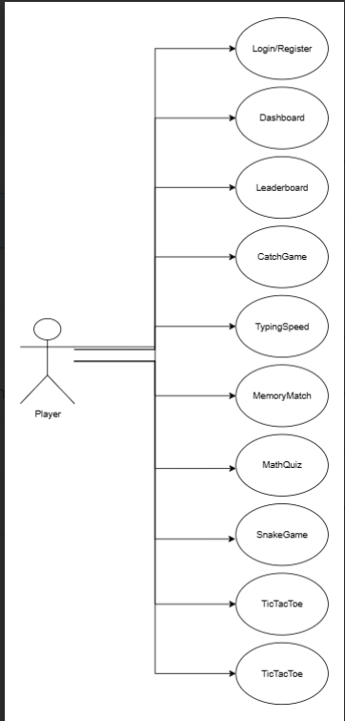

**3. Class Diagram (OOP)**

A class diagram shows how the system is structured using object-oriented concepts. For **Gamehub**, the main classes are:

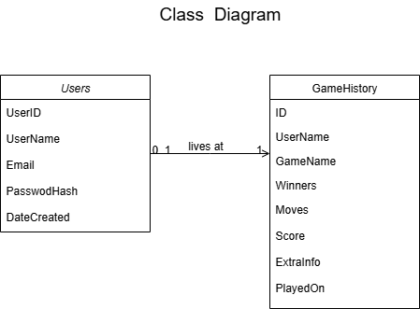

**Project Life Cycle**

A project life cycle explains the different phases of development, from planning and designing to implementation and testing. For **Gamehub**, the important design models used are **ER Diagram, Data Flow Diagram (DFD), and Activity Diagram**. These diagrams help in understanding how the system works internally and how the user interacts with it.

**1. ER Diagram (Entity–Relationship Diagram)**

The ER Diagram shows how different entities (tables) are related in the database.

**Entities for Gamehub:**

* **User** (UserID, Username, Password, Score)
* **Game** (GameID, GameName, Description, Rules)
* **Score** (ScoreID, UserID, GameID, Points, DatePlayed)

**Relationships:**

* A **User** can play many **Games**.
* A **Game** can be played by many **Users**.
* A **Score** table connects Users and Games to store results.

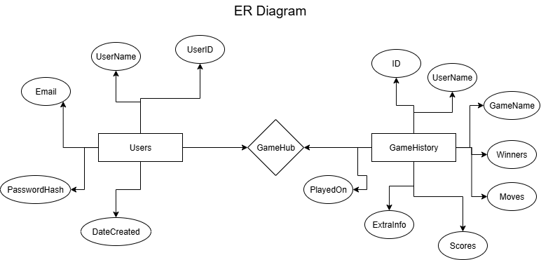

**2. Data Flow Diagram (DFD)**

A DFD explains how data moves in the system.

**Level 0 (Context Diagram)**

* **User** interacts with the **Gamehub System**.
* User provides login details → System checks database → System allows user to play game → System stores score in database.

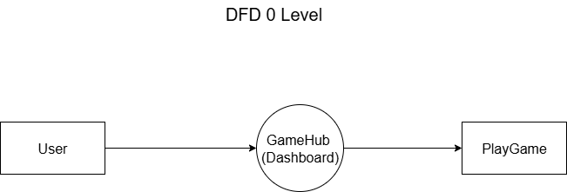

**Level 1 (Detailed Flow)**

1. **Login Process:** User enters username/password → System verifies from database.
2. **Game Selection:** User requests game list → System fetches available games from database.
3. **Play Game:** User plays the selected game → System runs game logic.
4. **Score Handling:** After game ends → System saves score into database → User can view score.

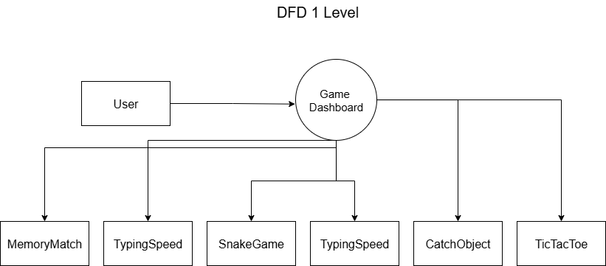

**3. Activity Diagram**

An activity diagram shows the step-by-step workflow of the system.

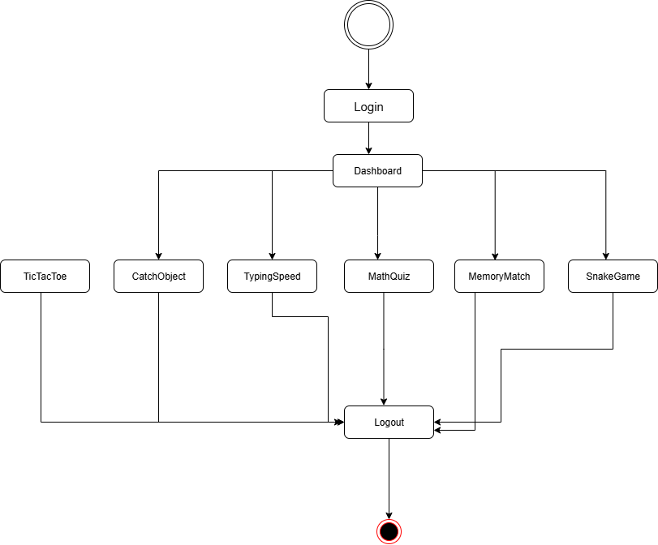

**Database Creation**

The **Gamehub project** uses **SQL Server** as the database. The main purpose of the database is to keep records of users and their game activities in a clear and secure way. To achieve this, the database design is kept simple with only two main tables: **Users** and **GameHistory**.

**Normalization of Tables (Issues & Solutions)**

**Issues Before Normalization:**

If all details about users and games were stored in a single table, then many problems would occur:

* Repeated storage of the same user details for every game played.
* Difficulty in updating or deleting information correctly.
* Higher storage requirement and data redundancy.
* Chances of inconsistency in user information.

**Solutions After Normalization:**

To solve these issues, normalization was applied:

1. **Users Table** is created separately to store user details such as username, email, and password.
2. **GameHistory Table** is created to store details of games played, including game name, score, moves, and date.
3. By linking the data through **Username**, duplication is avoided.

The database design follows **Third Normal Form (3NF)** because:

* Each field has atomic values (1NF).
* Data is divided into separate tables to avoid partial dependency (2NF).
* All non-key attributes depend only on the primary key (3NF).

This makes the database simple, clean, and easy to maintain.

**Data Dictionary**

**1. Users Table**

| **Field Name** | **Data Type** | **Description** |
| --- | --- | --- |
| UserID | INT (Primary Key) | Unique ID for each user |
| Username | VARCHAR | The name chosen by the user |
| Email | VARCHAR | User’s email address |
| PasswordHash | VARCHAR | Encrypted password for security |
| DateCreated | DATETIME | The date and time when the account was created |

**2. GameHistory Table**

| **Field Name** | **Data Type** | **Description** |
| --- | --- | --- |
| Id | INT (Primary Key) | Unique record ID for each game |
| Username | VARCHAR | Username of the player |
| GameName | VARCHAR | Name of the game played |
| Winner | VARCHAR | Winner of the match |
| Moves | INT | Number of moves in the game |
| Score | INT | Score achieved in the game |
| ExtraInfo | VARCHAR | Any additional information about the match |
| PlayedOn | DATETIME | The date and time when the game was played |

**Software Testing**

Software testing is an important step in the development of the **Gamehub project**. It makes sure that the system works correctly, gives the right results, and does not fail when users interact with it. Testing also helps to find errors before the project is delivered.

The Gamehub project is tested using different types of testing methods:

**1. Unit Testing**

* Each small part of the project, like **login module, registration, and game play**, is tested separately.
* For example, checking if the login form accepts only correct usernames and passwords.
* ASP.NET validation and SQL queries were tested step by step.

**2. Integration Testing**

* After testing single modules, they were combined together.
* Example: After registration, the user should be able to log in and then play a game.
* This testing ensured smooth connection between **Users Table** and **GameHistory Table**.

**3. Functional Testing**

* This was done to check if all project functions are working as expected.
* Some tested functions:
  + User can register successfully.
  + User can log in with valid details.
  + User can play a game.
  + Game results (winner, score, moves) are saved properly in the database.

**4. Validation Testing**

* The project was checked to confirm that it meets the requirements set during analysis.
* Example: Only registered users can access the game, and results are stored in history.

**5. User Acceptance Testing (UAT)**

* The system was tested from the user’s point of view.
* Users played games and checked if the system was easy to use, and if data was saved correctly.
* Feedback was collected and small improvements were made.

**6. Performance Testing**

* The project was tested for speed and performance.
* Example: Checking how fast the game history is stored and retrieved from the database.
* SQL queries were optimized for better performance.

**User Interface Designs (Snapshots)**

Login.aspx

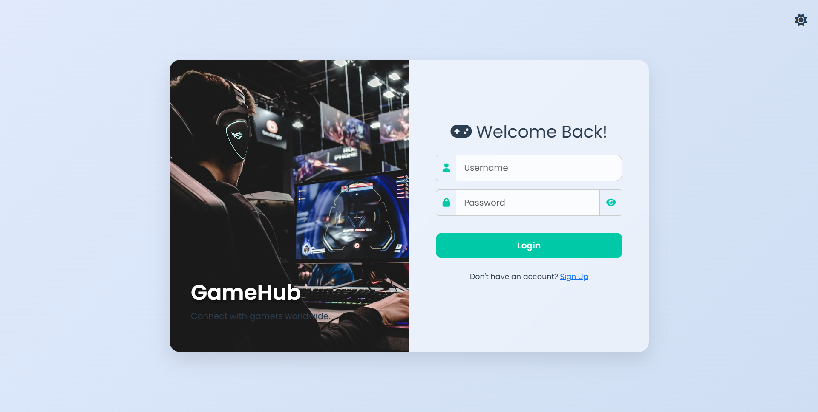

Register.aspx

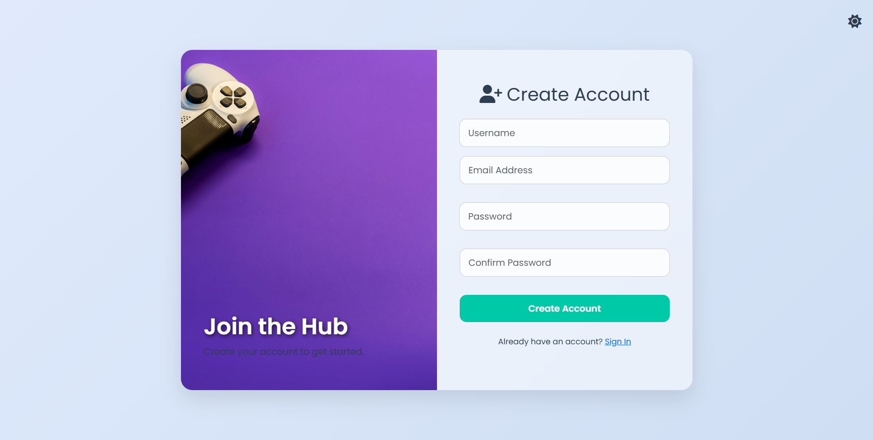

Dashboard.aspx

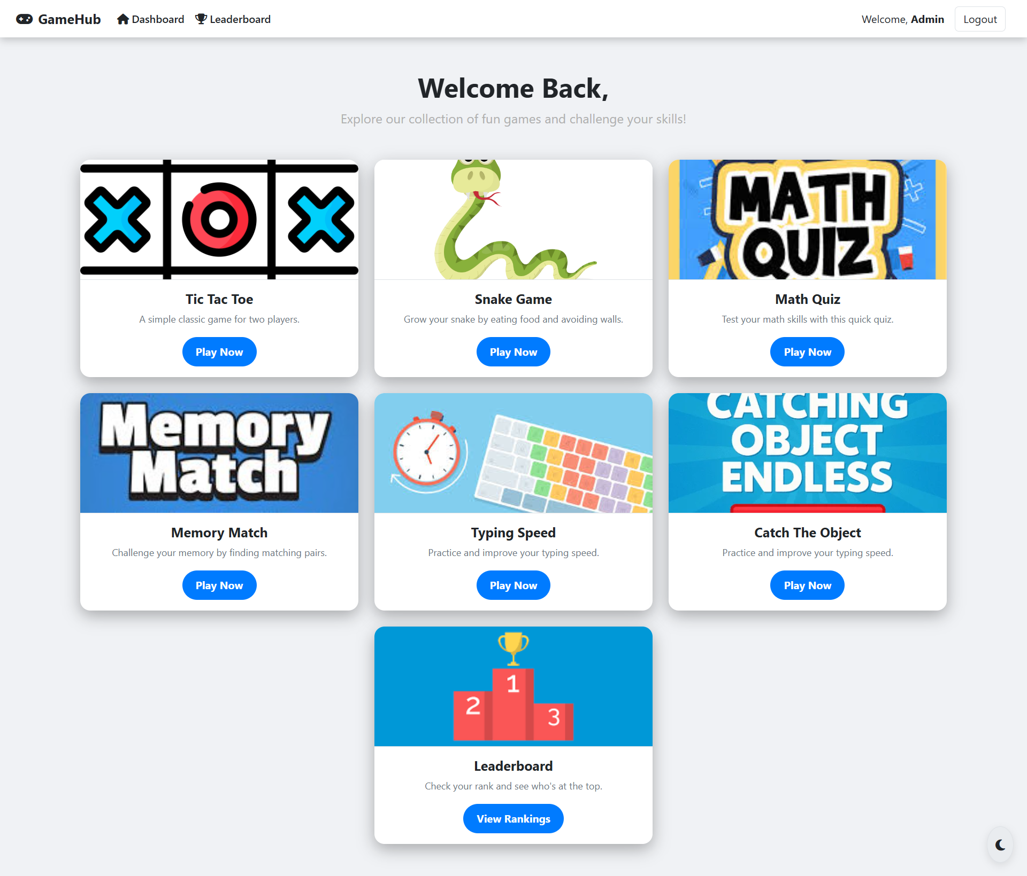

<%@ Page Language="C#" AutoEventWireup="true" CodeBehind="Dashboard.aspx.cs" Inherits="myprj.Dashboard" %>

<!DOCTYPE html>

<html lang="en">

<head>

<meta charset="UTF-8">

<title>GameHub | Dashboard</title>

<link rel="icon" href="data:image/svg+xml,<svg xmlns=%22http://www.w3.org/2000/svg%22 viewBox=%220 0 100 100%22><text y=%22.9em%22 font-size=%2290%22>🎮</text></svg>">

<meta name="viewport" content="width=device-width, initial-scale=1">

<link href="https://cdn.jsdelivr.net/npm/bootstrap@5.3.0/dist/css/bootstrap.min.css" rel="stylesheet">

<link href="https://cdnjs.cloudflare.com/ajax/libs/font-awesome/6.5.0/css/all.min.css" rel="stylesheet">

<style>

/*

* ------------------------

* THEME VARIABLES

* ------------------------

*/

:root {

--bg-main-dark: #121212;

--bg-secondary-dark: #1e1e1e;

--card-bg-dark: #282828;

--text-primary-dark: #e0e0e0;

--text-secondary-dark: #b0b0b0;

--accent-dark: #00e676;

--hover-dark: #00c853;

--border-dark: #444;

--bg-main-light: #f0f2f5;

--bg-secondary-light: #ffffff;

--card-bg-light: #e9ecef;

--text-primary-light: #212529;

--text-secondary-light: #6c757d;

--accent-light: #007bff;

--hover-light: #0056b3;

--border-light: #dee2e6;

}

/*

* ------------------------

* GLOBAL STYLES

* ------------------------

*/

body {

font-family: 'Segoe UI', sans-serif;

background-color: var(--bg-main-dark);

color: var(--text-primary-dark);

transition: background-color 0.3s, color 0.3s;

overflow-x: hidden;

}

.light-mode {

background-color: var(--bg-main-light);

color: var(--text-primary-light);

}

.light-mode .navbar, .light-mode .card, .light-mode .form-control {

background-color: var(--bg-secondary-light) !important;

border-color: var(--border-light) !important;

}

.light-mode .navbar-brand, .light-mode .nav-link, .light-mode h1, .light-mode h5 {

color: var(--text-primary-light) !important;

}

.light-mode .text-muted {

color: var(--text-secondary-light) !important;

}

.light-mode .btn-outline-secondary {

color: var(--text-primary-light);

border-color: var(--border-light);

}

.light-mode .btn-outline-secondary:hover {

background-color: var(--accent-light);

color: #fff;

}

.light-mode a {

color: var(--text-primary-light);

}

a {

text-decoration: none;

color: var(--text-primary-dark);

}

/*

* ------------------------

* NAVBAR STYLES

* ------------------------

*/

.navbar {

background-color: var(--bg-secondary-dark);

box-shadow: 0 4px 12px rgba(0, 0, 0, 0.2);

transition: background-color 0.3s;

}

.navbar-brand {

font-weight: bold;

color: var(--accent-dark);

transition: color 0.3s;

}

.nav-link {

font-weight: 500;

color: var(--text-primary-dark);

transition: color 0.3s;

}

.nav-link:hover {

color: var(--accent-dark);

}

.btn-outline-secondary {

color: var(--text-primary-dark);

border-color: var(--text-primary-dark);

transition: all 0.3s;

}

.btn-outline-secondary:hover {

background-color: var(--accent-dark);

color: var(--bg-secondary-dark);

border-color: var(--accent-dark);

}

/*

* ------------------------

* DASHBOARD CONTENT

* ------------------------

*/

.dashboard-header {

margin-top: 50px;

margin-bottom: 30px;

text-align: center;

}

.welcome-title {

font-size: 2.5rem;

font-weight: bold;

color: var(--accent-dark);

animation: fadeInDown 1.2s ease;

}

.welcome-subtitle {

font-size: 1.2rem;

color: var(--text-secondary-dark);

animation: fadeIn 2s ease-in;

}

.game-card {

background-color: var(--card-bg-dark);

border: none;

border-radius: 15px;

box-shadow: 0 8px 24px rgba(0, 0, 0, 0.3);

transition: transform 0.3s ease, box-shadow 0.3s ease;

height: 100%;

animation: cardFloat 0.6s ease forwards;

overflow: hidden;

}

.game-card:hover {

transform: translateY(-10px) scale(1.02);

box-shadow: 0 16px 40px rgba(0, 230, 118, 0.4);

}

.card-img-top {

height: 180px;

object-fit: cover;

border-bottom: 1px solid var(--border-dark);

}

.light-mode .card-img-top {

border-bottom: 1px solid var(--border-light);

}

.card-body h5 {

font-weight: bold;

color: var(--text-primary-dark);

transition: color 0.3s;

}

.card-body p {

font-size: 0.9rem;

color: var(--text-secondary-dark);

transition: color 0.3s;

}

.play-btn {

background-color: var(--accent-dark);

color: var(--bg-main-dark);

border: none;

font-weight: bold;

padding: 10px 20px;

border-radius: 50px;

transition: background-color 0.3s, transform 0.3s;

}

.play-btn:hover {

background-color: var(--hover-dark);

transform: translateY(-2px);

}

.light-mode .play-btn {

background-color: var(--accent-light);

color: #fff;

}

.light-mode .play-btn:hover {

background-color: var(--hover-light);

}

/*

* ------------------------

* THEME TOGGLE

* ------------------------

*/

.theme-toggle {

position: fixed;

bottom: 20px;

right: 20px;

background: var(--card-bg-dark);

border: 1px solid var(--border-dark);

border-radius: 50%;

padding: 12px;

font-size: 1.2rem;

cursor: pointer;

color: var(--text-primary-dark);

transition: all 0.3s ease;

box-shadow: 0 4px 12px rgba(0, 0, 0, 0.3);

z-index: 100;

}

.theme-toggle:hover {

transform: scale(1.1) rotate(20deg);

}

.light-mode .theme-toggle {

background: var(--card-bg-light);

color: var(--text-primary-light);

border: 1px solid var(--border-light);

box-shadow: 0 4px 12px rgba(0, 0, 0, 0.1);

}

/*

* ------------------------

* ANIMATIONS

* ------------------------

*/

@keyframes fadeInDown {

from { opacity: 0; transform: translateY(-20px); }

to { opacity: 1; transform: translateY(0); }

}

@keyframes fadeIn {

from { opacity: 0; }

to { opacity: 1; }

}

@keyframes cardFloat {

from { opacity: 0; transform: translateY(20px); }

to { opacity: 1; transform: translateY(0); }

}

</style>

</head>

<body>

<form id="form1" runat="server">

<nav class="navbar navbar-expand-lg">

<div class="container-fluid px-4">

<a class="navbar-brand" href="#">

<i class="fas fa-gamepad me-2"></i>GameHub

</a>

<button class="navbar-toggler" type="button" data-bs-toggle="collapse" data-bs-target="#navbarNav" aria-controls="navbarNav" aria-expanded="false" aria-label="Toggle navigation">

<span class="navbar-toggler-icon"></span>

</button>

<div class="collapse navbar-collapse" id="navbarNav">

<ul class="navbar-nav me-auto mb-2 mb-lg-0">

<li class="nav-item">

<a class="nav-link active" aria-current="page" href="#"><i class="fas fa-home me-1"></i>Dashboard</a>

</li>

<li class="nav-item">

<a class="nav-link" href="Leaderboard.aspx"><i class="fas fa-trophy me-1"></i>Leaderboard</a>

</li>

</ul>

<div class="d-flex align-items-center">

<span class="me-3 d-none d-lg-block">Welcome, <asp:Label ID="lblUser" runat="server" CssClass="fw-bold" /></span>

<asp:Button ID="btnLogout" runat="server" Text="Logout" CssClass="btn btn-outline-secondary me-2" OnClick="btnLogout_Click" />

</div>

</div>

</div>

</nav>

<div class="dashboard-header text-center">

<h1 class="welcome-title">Welcome Back, <asp:Label ID="lblUserHeader" runat="server" /></h1>

<p class="welcome-subtitle">Explore our collection of fun games and challenge your skills!</p>

</div>

<div class="container my-5">

<div class="row g-4 justify-content-center">

<div class="col-lg-4 col-md-6 col-sm-10">

<a href="TicTacToe.aspx">

<div class="card game-card">

<img src="Images/tic-tac-toe.png" class="card-img-top" alt="Tic Tac Toe">

<div class="card-body text-center">

<h5 class="card-title">Tic Tac Toe</h5>

<p class="card-text text-muted">A simple classic game for two players.</p>

<button type="button" class="btn play-btn">Play Now</button>

</div>

</div>

</a>

</div>

<div class="col-lg-4 col-md-6 col-sm-10">

<a href="SnakeGame.aspx">

<div class="card game-card">

<img src="Images/snackgame.png" class="card-img-top" alt="Snake Game">

<div class="card-body text-center">

<h5 class="card-title">Snake Game</h5>

<p class="card-text text-muted">Grow your snake by eating food and avoiding walls.</p>

<button type="button" class="btn play-btn">Play Now</button>

</div>

</div>

</a>

</div>

<div class="col-lg-4 col-md-6 col-sm-10">

<a href="MathQuiz.aspx">

<div class="card game-card">

<img src="Images/mathquiz.jpg" class="card-img-top" alt="Math Quiz">

<div class="card-body text-center">

<h5 class="card-title">Math Quiz</h5>

<p class="card-text text-muted">Test your math skills with this quick quiz.</p>

<button type="button" class="btn play-btn">Play Now</button>

</div>

</div>

</a>

</div>

<div class="col-lg-4 col-md-6 col-sm-10">

<a href="MemoryMatch.aspx">

<div class="card game-card">

<img src="Images/memory-match.jpg" class="card-img-top" alt="Memory Match">

<div class="card-body text-center">

<h5 class="card-title">Memory Match</h5>

<p class="card-text text-muted">Challenge your memory by finding matching pairs.</p>

<button type="button" class="btn play-btn">Play Now</button>

</div>

</div>

</a>

</div>

<div class="col-lg-4 col-md-6 col-sm-10">

<a href="TypingSpeed.aspx">

<div class="card game-card">

<img src="Images/typingspeed.jpg" class="card-img-top" alt="Typing Speed">

<div class="card-body text-center">

<h5 class="card-title">Typing Speed</h5>

<p class="card-text text-muted">Practice and improve your typing speed.</p>

<button type="button" class="btn play-btn">Play Now</button>

</div>

</div>

</a>

</div>

<div class="col-lg-4 col-md-6 col-sm-10">

<a href="CatchGame.aspx">

<div class="card game-card">

<img src="Images/catch_object.png" class="card-img-top" alt="Typing Speed">

<div class="card-body text-center">

<h5 class="card-title">Catch The Object</h5>

<p class="card-text text-muted">Practice and improve your typing speed.</p>

<button type="button" class="btn play-btn">Play Now</button>

</div>

</div>

</a>

</div>

<div class="col-lg-4 col-md-6 col-sm-10">

<a href="Leaderboard.aspx">

<div class="card game-card">

<img src="Images/leaderboard.png" class="card-img-top" alt="Leaderboard">

<div class="card-body text-center">

<h5 class="card-title">Leaderboard</h5>

<p class="card-text text-muted">Check your rank and see who's at the top.</p>

<button type="button" class="btn play-btn">View Rankings</button>

</div>

</div>

</a>

</div>

</div>

</div>

</form>

<button type="button" class="theme-toggle" id="themeToggle" aria-label="Toggle Theme">

<i id="themeIcon" class="fas fa-sun"></i>

</button>

<script src="https://cdn.jsdelivr.net/npm/bootstrap@5.3.0/dist/js/bootstrap.bundle.min.js"></script>

<script>

const toggleButton = document.getElementById('themeToggle');

const icon = document.getElementById('themeIcon');

const body = document.body;

// Load theme from localStorage

const currentTheme = localStorage.getItem('theme');

if (currentTheme) {

body.classList.add(currentTheme + '-mode');

icon.classList.remove('fa-sun', 'fa-moon');

icon.classList.add(currentTheme === 'light' ? 'fa-moon' : 'fa-sun');

}

toggleButton.addEventListener('click', () => {

const isLight = body.classList.contains('light-mode');

// Toggle classes on the body

body.classList.toggle('light-mode', !isLight);

body.classList.toggle('dark-mode', isLight);

// Toggle classes on the icon

icon.classList.toggle('fa-sun', isLight);

icon.classList.toggle('fa-moon', !isLight);

// Save preference to localStorage

localStorage.setItem('theme', isLight ? 'dark' : 'light');

});

</script>

</body>

</html>  
Dashboard.aspx.cs

using System;

namespace myprj

{

public partial class Dashboard : System.Web.UI.Page

{

protected void Page_Load(object sender, EventArgs e)

{

if (Session["Username"] == null)

{

Response.Redirect("Login.aspx");

}

else

{

string fullEmail = Session["Username"].ToString();

// Take only the part before '@'

string displayName = fullEmail.Split('@')[0];

// Replace underscores and dots with spaces

displayName = displayName.Replace("_", " ").Replace(".", " ");

// Capitalize first letter if not empty

if (!string.IsNullOrEmpty(displayName))

{

displayName = char.ToUpper(displayName[0]) + displayName.Substring(1);

}

lblUser.Text = displayName;

}

}

protected void btnLogout_Click(object sender, EventArgs e)

{

Session.Abandon();

Response.Redirect("Login.aspx");

}

}

}

TicTacToe.aspx

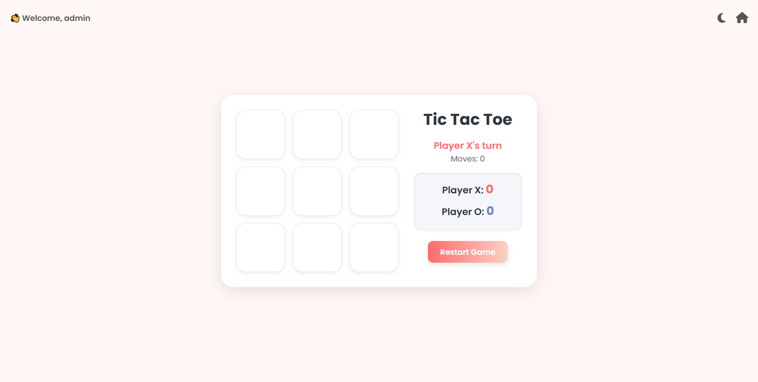

SnakeGame.aspx

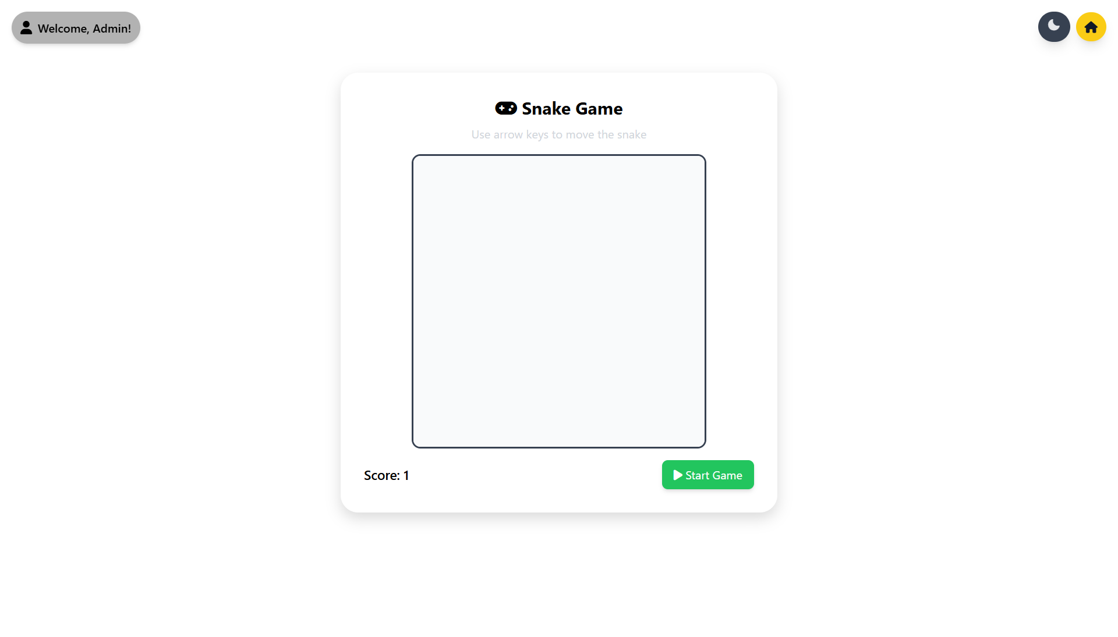

MathQuiz.aspx

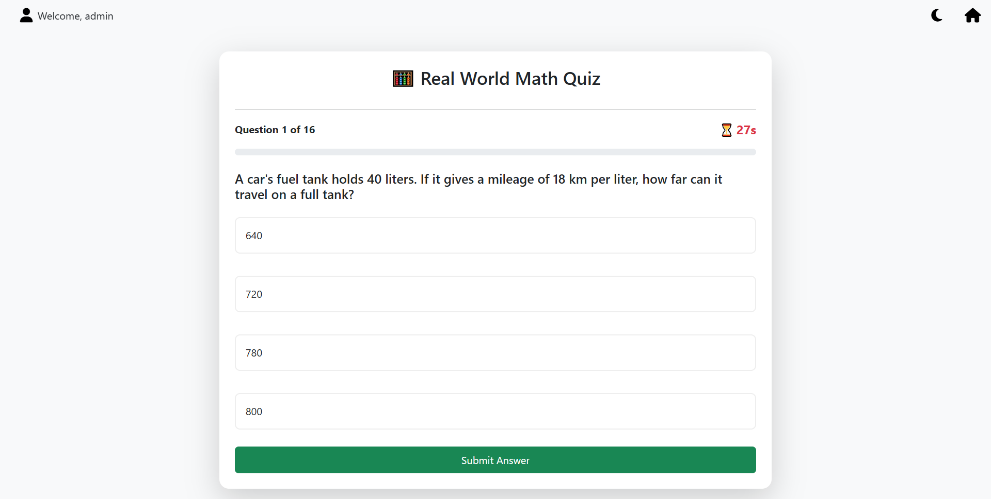

MemoryMatch.aspx

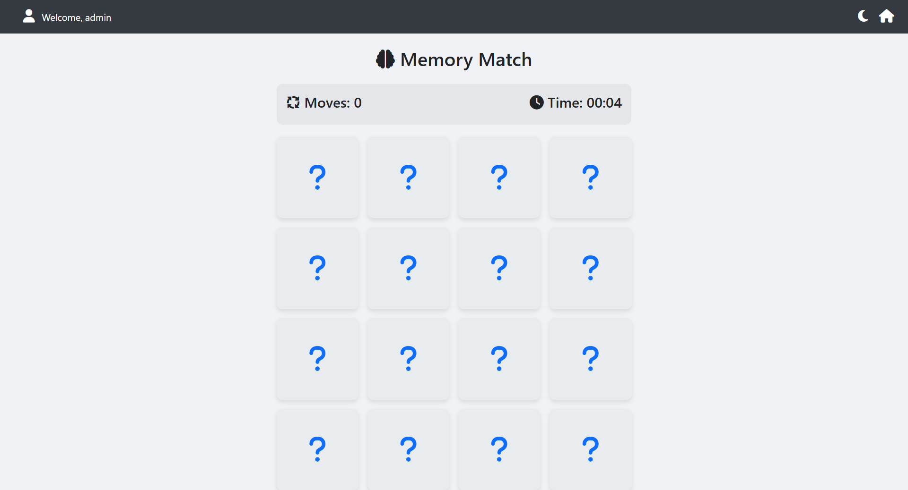

TypingSpeed.aspx

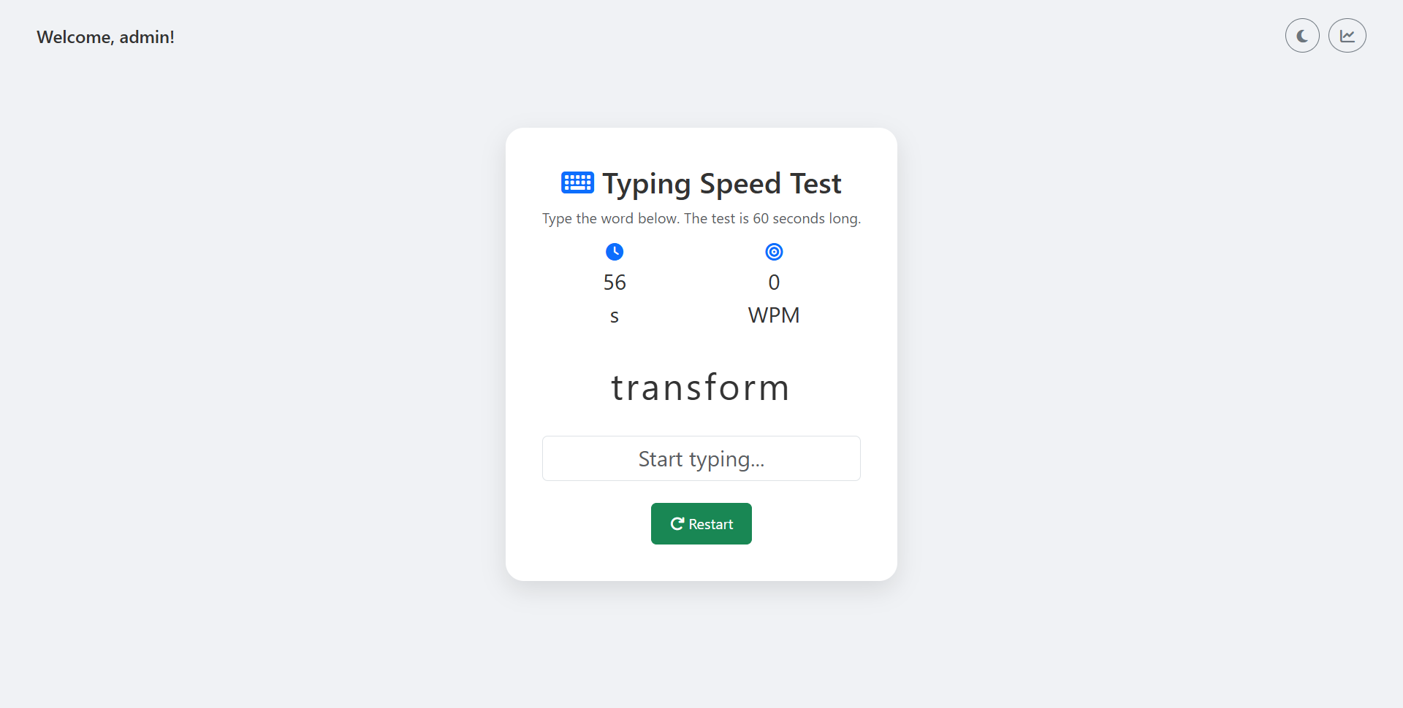

CatchGame.aspx

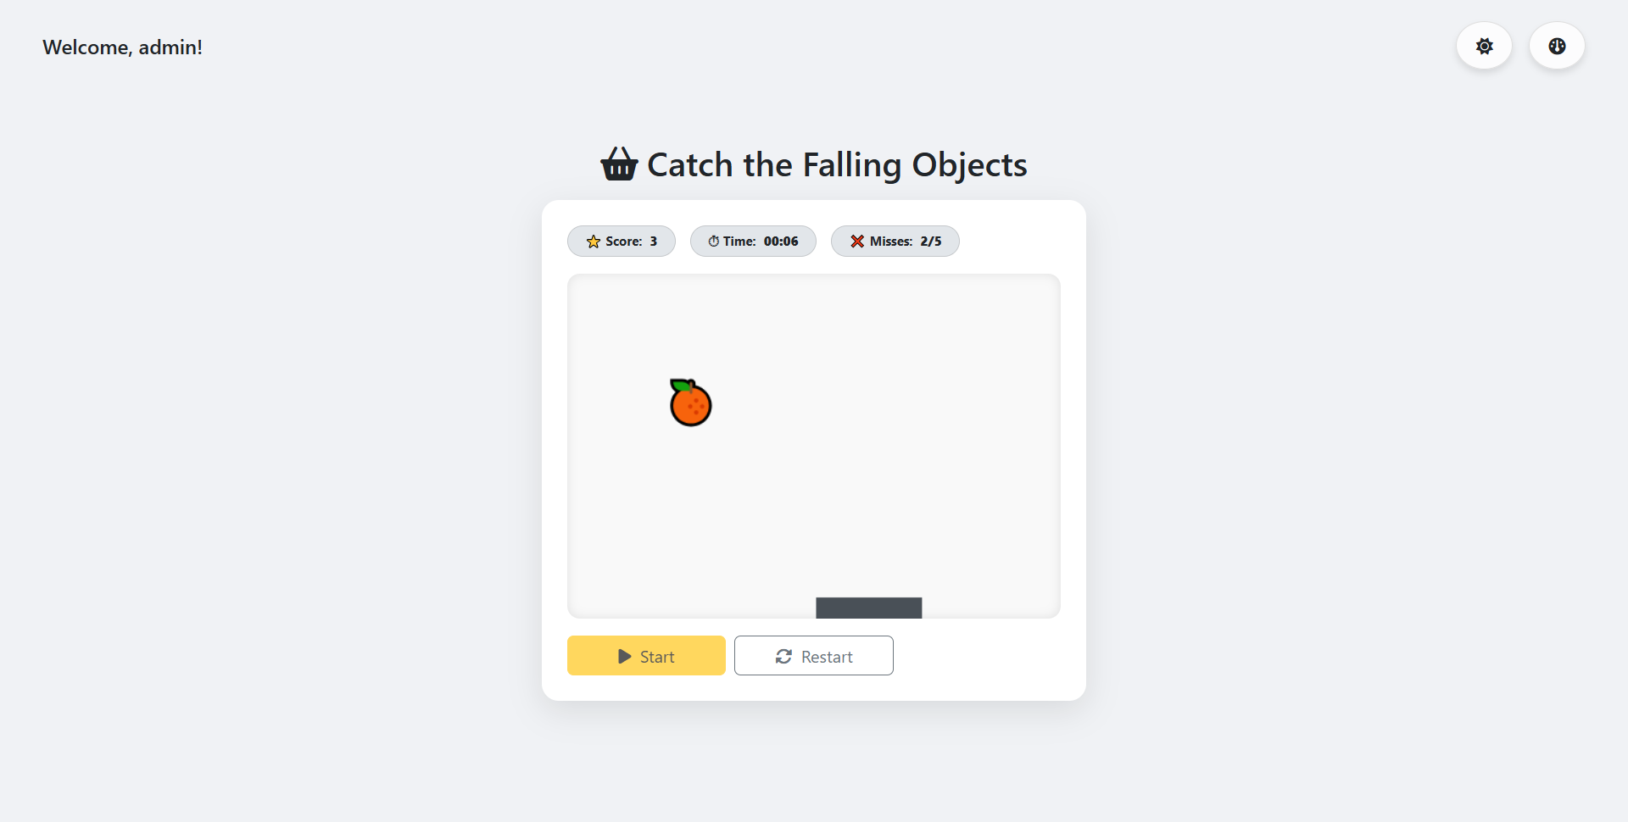

Leaderboard.aspx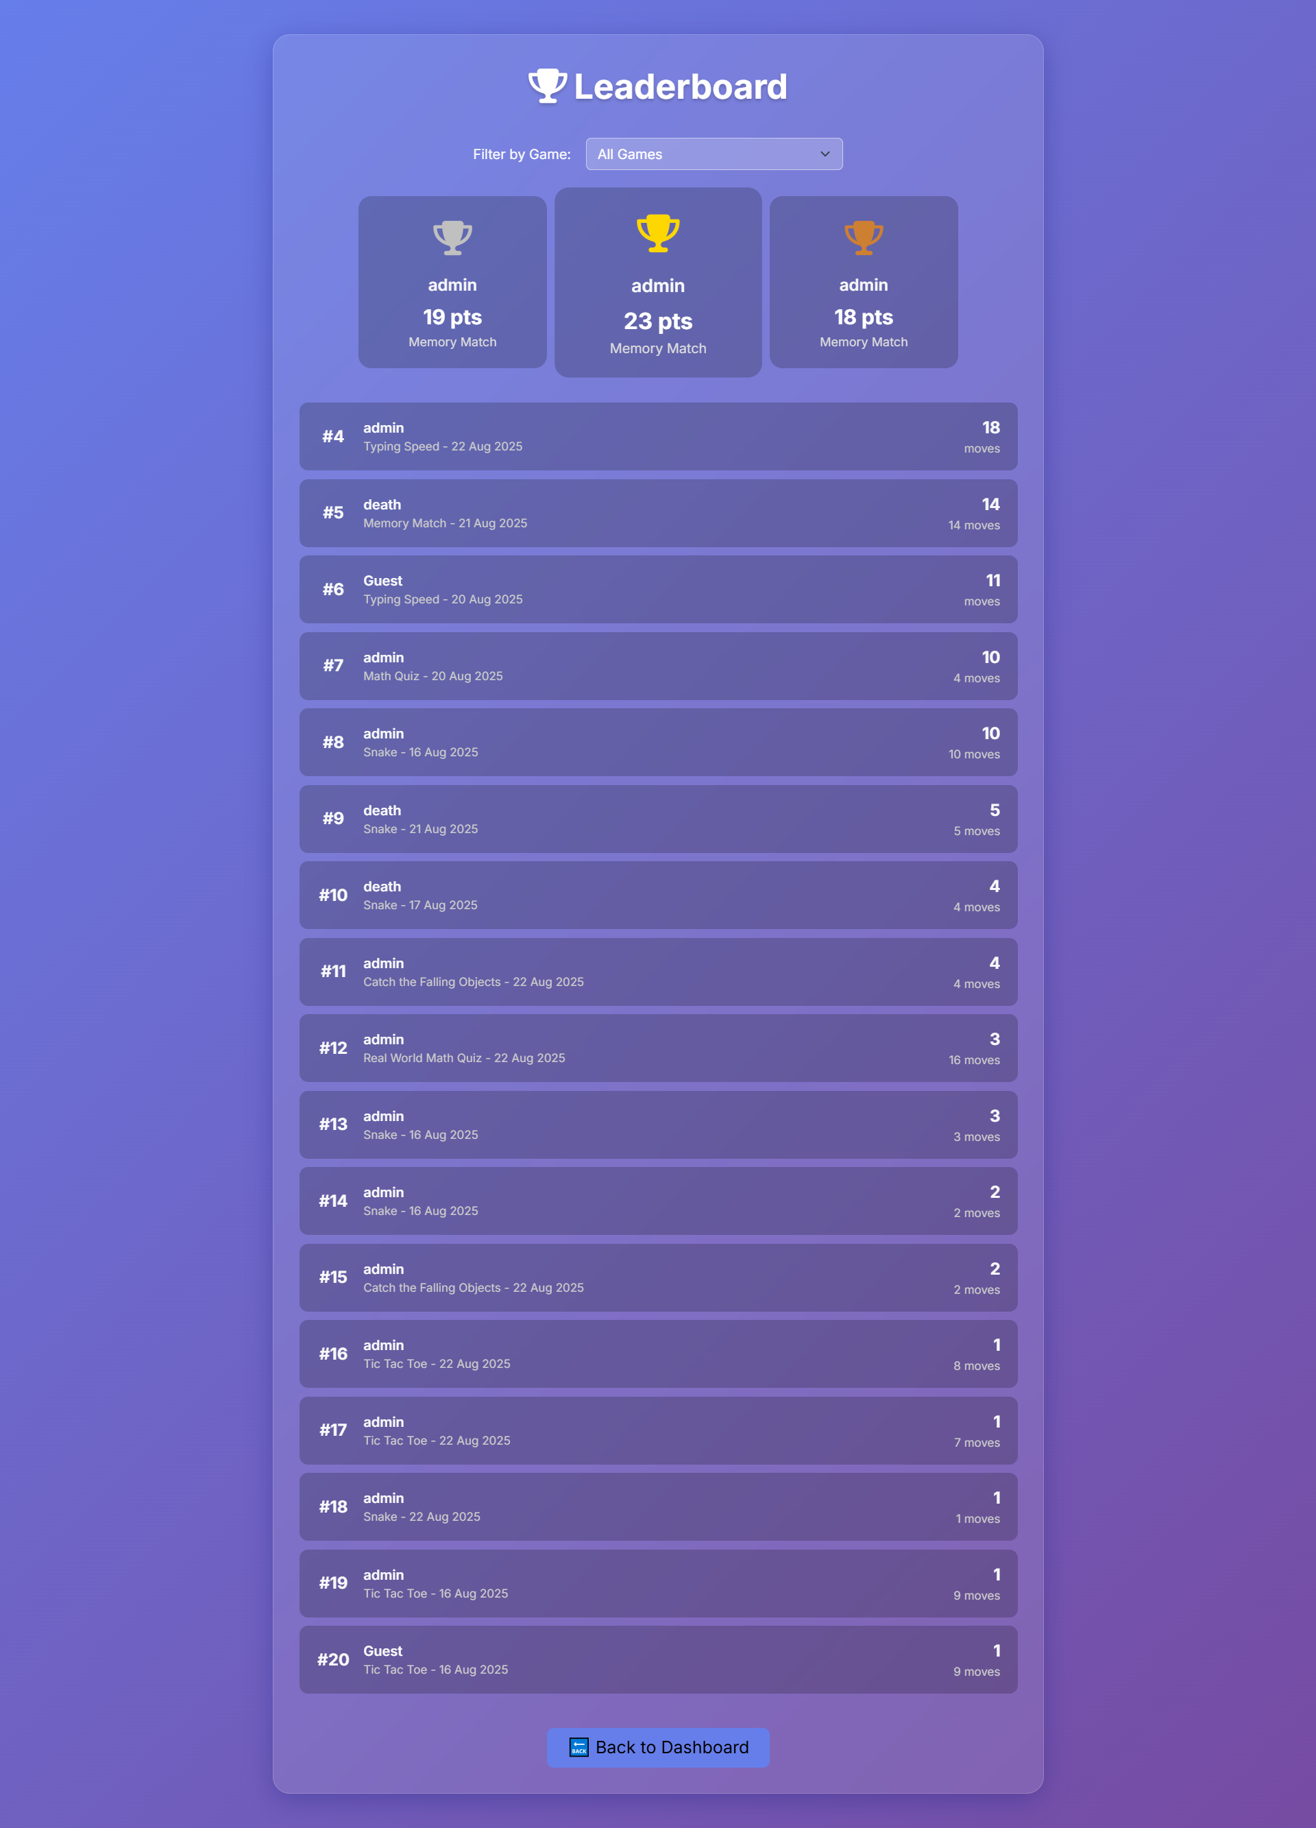

# Bibliography

1. Asp.Net Documentation, Microsoft Docs, https://docs.microsoft.com/aspnet/
2. SQL Server Documentation, Microsoft Docs, https://docs.microsoft.com/sql/
3. Himanshu Solanki, *Gamehub Project Report*, Dr. V.R. Godhaniya I.T. College, Bhakta Kavi Narsinh Mehta University, Porbandar.
4. W3Schools, “ASP.NET Tutorial”, https://www.w3schools.com/aspnet/
5. TutorialsPoint, “SQL Server Tutorial”, https://www.tutorialspoint.com/sql_server/
6. Pressman, Roger S., *Software Engineering: A Practitioner’s Approach*, McGraw Hill Education, 8th Edition.